Lesson 24: Flood Warning

1.Raindrop sensor:
Raindrop sensor is a kind of sensing device, which is mainly used to detect whether it rains and the amount of rain, and is widely used in automobile automatic wiper system, intelligent lighting system and intelligent sunroof system. It consists of two parts, one is a sensor panel for detecting rainwater, and the other is a control module that converts the detected signal into an electrical signal.
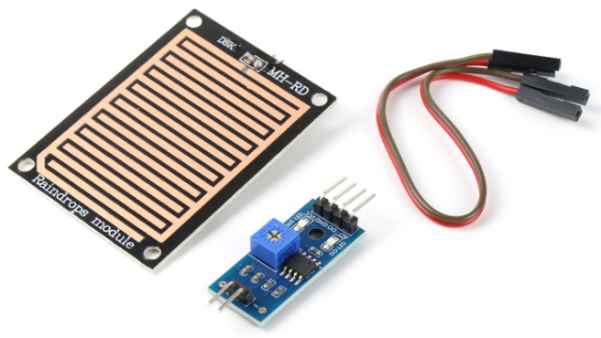

2.Project Introduction:
It simulates the flood control alarm system, judges whether there is a flood disaster through the amount of rain detected by the sensor panel of the raindrop sensor, and then controls the buzzer to emit a siren sound and displays the alarm information on the LCD1602 LCD screen.
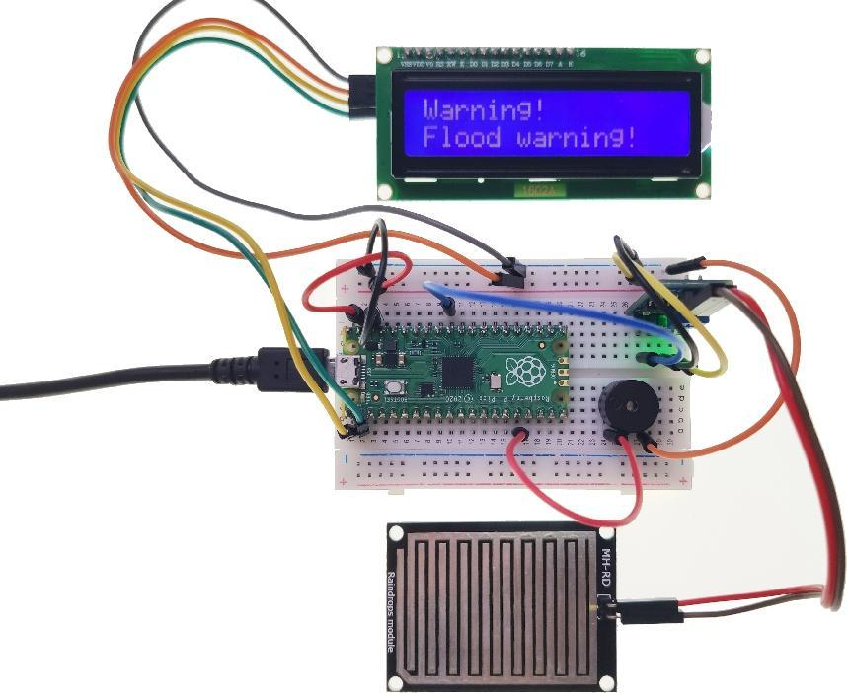

3.Circuit connection:
3.1 Material preparation: Raspberry Pi Pico*1, USB cable*1, Breadboard*1, Raindrop sensor*1, LCD1602*1, Buzzer*1, Dupont line;
3.2 Port connection:
Raspberry Pi Pico | Raindrop sensor
GND | GND
VSYS | VCC
-- | DO
GP26(ADC0) | AO

Raspberry Pi Pico | LCD1602
GP0 | SDA
GP1 | SCL
VSYS | VCC ( + )
GND | GND ( - )

Raspberry Pi Pico | Buzzer
GND | GND
GP12 | VCC ( + )

4.Library file installation:
Upload the “i2c_lcd.py” and “i2c_api.py” library file to the Raspberry Pi Pico. For the specific operation steps, please refer to Lesson 16.

5.Program analysis: Flood Warning
from machine import Pin,ADC,PWM,I2C
from i2c_lcd import I2cLcd
from time import sleep

DEFAULT_I2C_ADDR = 0x27 # LCD 1602 I2C address
# If 0x27 doesn't respond then 0x3f is used
Raindrop_AO = ADC(0) # ADC0 multiplexing pin is GP26
Buzzer = 12
buzzer = PWM(Pin(Buzzer))

def setup():
global lcd
i2c = I2C(0,sda=Pin(0),scl=Pin(1),freq=400000)
lcd = I2cLcd(i2c, DEFAULT_I2C_ADDR, 2, 16)

def loop():
while True:
text = 'Warning!\nFlood warning!' # show alert information
adc_Raindrop =Raindrop_AO.read_u16()
if adc_Raindrop < 30000:
lcd.putstr(text)
buzzer.duty_u16(1000)
buzzer.freq(294)
sleep(0.5)
lcd.clear()
buzzer.freq(495)
sleep(0.5)
else:
buzzer.duty_u16(0)

if __name__ == '__main__':
setup()
loop()

